Theme: The Environment

Key Content (Part 2)

Quotes/Good Introduction/Add value to Conclusion:

- “It is not too late to admit that we have failed.” Greta Thunberg’s solemn warning poignantly underlines our government’s obsession with economic growth that has come at the expense of our environment.

- “We do not inherit the Earth from our ancestors, we borrow it from our children.” said Emerson, the 19th century American Essayist and Poet. His quote lends credence to the idea that we must take action if we want to pass on a world with a healthy environment to future generations

Key Debates in Environment since 2020

Debate | Key Tensions | Main Stakeholders | Recent Examples
 | Tension arises between rich and poor nations over responsibility: developed countries push for global emission cuts, while developing countries argue for greater support to adapt to floods, droughts, and rising sea levels caused by climate change they did not largely create. | Governments, UNFCCC, climate scientists, disaster management agencies | At COP28, fossil fuel producers resisted calls for a complete phase-out, while vulnerable island states demanded urgent commitments, highlighting global disparities in climate impact.
 | Governments and industries face pressure to abandon fossil fuels for renewables, but concerns persist over energy reliability, affordability, and job losses in traditional sectors. There's also debate over whether nuclear and hydrogen technologies should be part of the transition. | Governments, energy companies, environmental NGOs, workers’ unions | Germany’s nuclear phase-out contrasts with France’s continued use of nuclear power to meet climate targets. Meanwhile, China became the top exporter of solar panels, dominating the global clean energy supply chain and reshaping geopolitical energy dependencies.
 | The unequal impact of environmental degradation leads to calls for justice. Rich countries, historically major polluters, are urged to compensate poorer nations now suffering climate-related disasters. The fairness of burden-sharing is hotly debated, especially over climate finance and reparations. | Global South nations, UN, aid agencies, civil society, vulnerable communities | The Loss and Damage Fund, formalised in 2023, compensates nations suffering from climate change, but sparked debates over accountability and sufficiency of contributions.
Nature Conservation vs Development | Efforts to conserve biodiversity often clash with national economic goals like infrastructure and agriculture expansion. Additionally, protected areas can restrict indigenous communities’ access to ancestral lands, sparking debates about whose priorities should prevail. | Environmentalists, developers, indigenous groups, local governments | Under President Lula, Brazil resumed efforts to curb Amazon deforestation by empowering indigenous communities and penalising illegal loggers. However, agribusiness interests continue to push for land use, leading to domestic and international tensions.
 | Corporations increasingly brand themselves as sustainable, but many are accused of greenwashing—making misleading claims to appear environmentally responsible. Critics argue for stricter regulations, while businesses often prefer self-regulation to maintain flexibility and public image. | Corporations, regulators, watchdog groups, consumers | Major oil companies like Shell and BP faced lawsuits for misleading 'net-zero' advertisements, which claimed sustainability while continuing fossil fuel exploration. Watchdog groups argued this misled consumers and investors, triggering legal and public backlash.
 | Geoengineering is proposed as a last-resort solution to cool the planet, but it faces criticism for potential side effects and ethical dilemmas about governance. Some fear it could distract from emission cuts or trigger geopolitical conflicts over climate manipulation. | Scientists, ethicists, global policymakers, UN bodies | US-backed solar geoengineering trials drew criticism for governance risks, ethical concerns, and fears from Global South nations over unintended climatic side effects.
 | The need to feed growing populations sustainably drives debate over intensive farming versus regenerative methods. Issues include methane emissions from livestock, deforestation for agriculture, and whether technology like lab-grown meat or GMOs should be embraced. | Farmers, consumers, agro-industry, nutritionists, policymakers | The EU's strategy promoting sustainable farming was challenged by farmers fearing reduced crop yields due to strict pesticide and fertiliser regulations.
 | Urban growth raises concerns over sprawl, pollution, and resource use. Green infrastructure like parks and public transport is promoted, but planning must balance density, affordability, and inclusivity to avoid social or environmental trade-offs. | Urban planners, governments, private developers, citizens | Singapore’s Green Plan 2030 prioritised cycling paths, solar panels, and electric vehicles, but affordability of eco-homes and inclusivity remain concerns. Paris’s 15-minute city initiative also gained traction, promoting urban living within walking distance of essential services.
 | Plastic pollution is a major threat to ecosystems. While some countries advocate capping plastic production, others push for improved recycling. The debate also includes whether producers or consumers should bear the greater responsibility for waste management. | UN, plastic industry, environmental NGOs, consumers | At UN-led negotiations for a Global Plastics Treaty, Kenya and Chile advocated production caps, while plastic-producing nations like the U.S. promoted recycling solutions. Civil society groups warned of corporate influence diluting treaty strength.
 | Using market tools like biodiversity credits to fund conservation efforts sparks concern over commodifying nature. There’s tension between attracting private finance and ensuring local communities and ecosystems are genuinely protected and not exploited for profit. | Conservation NGOs, carbon market investors, indigenous communities | Africa’s biodiversity credit market drew scrutiny for lack of transparency and excluding local communities from conservation benefits.

COP28

COP28 marked a historic moment by finally acknowledging the need to move away from fossil fuels, but the lack of enforceable commitments and continued compromises left many stakeholders frustrated. The summit revealed deep global divides—between high- and low-income countries, fossil fuel exporters and climate-vulnerable nations—underscoring the complex politics of global climate action.

Global Reactions
- UN Secretary-General António Guterres: Welcomed progress but warned of inadequate ambition.
- Small Island Developing States (SIDS): Expressed disappointment that the deal lacked legally binding fossil fuel phase-out.
- Climate activists: Praised the mention of fossil fuels but condemned the perceived greenwashing and slow pace.

Key Themes and Outcomes

1. Global Stocktake (GST) – First-Ever Review
- Purpose: To assess collective progress towards the Paris Agreement goal of limiting global warming to 1.5°C.
- Findings: The world is not on track – current national pledges (NDCs) will lead to warming of about 2.5°C–2.9°C.
- Implication: Urgent need for stronger, faster emissions cuts and policy shifts.

2. Fossil Fuel Debate – Historic but Contested
- For the first time in COP history, the final agreement called for a “transition away from fossil fuels.”
- Language avoided stronger phrases like “phase-out,” a compromise made to placate oil-producing nations.
- Over 100 countries supported stronger language, but were blocked by OPEC members (especially Saudi Arabia and Russia).
- Activists viewed it as progress but also criticised the watering down of ambition.

3. Tripling Renewable Energy by 2030
- Countries agreed to triple global renewable energy capacity and double energy efficiency improvements by 2030.
- Seen as a concrete goal with measurable outcomes.
- Challenge: Financing and implementation in the Global South.

4. Loss and Damage Fund Operationalised
- Originally proposed in COP27, the fund was officially launched at COP28.
- Initial pledges exceeded $700 million from countries like the UAE, Germany, and the EU.
- Criticism: Pledged sums are small compared to the estimated $400 billion/year needed by vulnerable countries.

5. Climate Finance
- Ongoing concern that developed nations have failed to meet the $100 billion/year pledge made in 2009.
- COP28 reiterated the need to reform international financial institutions (e.g. IMF, World Bank) to support climate transitions.
- Push for more private sector involvement and innovative mechanisms.

6. Methane and Other Greenhouse Gases
- Over 150 countries signed the Global Methane Pledge, committing to reduce methane emissions by 30% by 2030.
- The oil and gas industry was pressed to cut flaring and methane leaks, but critics noted voluntary compliance may be insufficient.

7. Youth, Indigenous, and Civil Society Engagement
- Record participation by civil society, youth, and indigenous leaders.
- Calls for climate justice, recognition of historical responsibility, and gender-inclusive policy gained prominence.
- Tensions remained over access and influence, especially with COP28’s heavy presence of fossil fuel lobbyists.

COP29

The 29th United Nations Climate Change Conference (COP29) convened in Baku, Azerbaijan, from November 11 to 22, 2024. Dubbed the "Finance COP," the summit centered on climate finance, carbon markets, and support for vulnerable nations.

COP29 marked a significant step in climate finance discussions but highlighted ongoing challenges in achieving global consensus on climate action. The outcomes set the stage for further negotiations and commitments at COP30, scheduled to be held in Belém, Brazil, in 2025.

Controversies and Criticisms
- Insufficient Ambition: Many developing nations criticized the $300 billion annual finance goal as inadequate, emphasizing the urgent need for more substantial funding to address climate challenges.
- Fossil Fuel Influence: The absence of strong language on phasing out fossil fuels drew criticism, especially given Azerbaijan's status as a major oil and gas producer.
- Human Rights Concerns: Hosting COP29 in Azerbaijan raised concerns due to the country's human rights record and allegations of suppressing dissenting voices during the conference.

Key Outcomes from COP29

1. New Climate Finance Goal: $300 Billion by 2035
- Developed countries committed to mobilizing at least $300 billion annually by 2035 to assist developing nations in climate mitigation and adaptation efforts.
- This figure triples the previous $100 billion annual pledge but falls short of the $1.3 trillion per year that many developing countries advocated for.

2. "Baku to Belém Roadmap to $1.3 Trillion"
- A non-binding roadmap was introduced to scale up global climate finance to $1.3 trillion annually by 2035, combining public and private sources.
- The roadmap aims to bridge the gap between current commitments and the financial needs of developing countries.

3. Operationalization of the Loss and Damage Fund
- The Loss and Damage Fund, established at COP27, was declared operational and ready to receive contributions, with disbursements expected to begin in 2025.
- The fund is designed to support countries facing irreversible climate impacts.

4. Carbon Market Framework Finalized
- After years of negotiations, COP29 finalized the framework for international carbon credit trading under Article 6.4 of the Paris Agreement.
- This development is expected to unlock significant funding for climate projects in developing countries.

2015 Paris Agreement

Main Objective
To limit global warming to well below 2°C above pre-industrial levels and to pursue efforts to limit the increase to 1.5°C, recognising that this would significantly reduce the risks and impacts of climate change.

Key Provisions and Commitments:

1. Nationally Determined Contributions (NDCs)
- Each country must submit its own voluntary climate action plan, known as an NDC.
- NDCs include emissions reduction targets, adaptation strategies, and finance plans.
- Countries must update and strengthen their NDCs every five years.
- First update: 2020 (delayed due to COVID-19); subsequent update in 2025.

2. Transparency and Accountability
- Countries must report regularly on emissions, progress toward goals, and climate actions using a common transparency framework.
- An expert review process and global stocktake (every 5 years) assess collective progress.

3. Global Stocktake
- A periodic assessment of collective efforts, starting in 2023, to check whether the world is on track to meet long-term goals.
- Results guide countries in enhancing ambition in future NDCs.

4. Climate Finance
- Developed countries reaffirmed their pledge to mobilise $100 billion annually by 2020 to support developing countries.
- Funds are meant for mitigation, adaptation, capacity building, and technology transfer.
- A new climate finance goal is to be set for post-2025.

5. Loss and Damage
- Recognised for the first time in a UN climate agreement.
- Acknowledges the need to address irreversible damage caused by climate change (e.g., rising seas, loss of livelihoods).
- Implementation remains non-binding and under negotiation.

6. Non-State Actor Involvement
- The Agreement opened space for cities, businesses, NGOs, and civil society to contribute to climate action.
- Led to initiatives like the Race to Zero and UNFCCC Climate Champions.
Significance of the Paris Agreement
- First universal, legally binding climate framework where all nations agreed to act.
- Marked a shift from top-down targets (like Kyoto Protocol) to bottom-up nationally set commitments.
- Emphasised the principle of “common but differentiated responsibilities” – all must act, but in line with their capacities.

Strengths
- Inclusive and near-universal participation
- Dynamic framework allowing increased ambition over time
- Emphasis on equity, transparency, and long-term planning

Limitations
- NDCs are not legally binding; no enforcement mechanism for non-compliance
- Current pledges (as of 2024) put the world on track for 2.5°C–2.9°C of warming
- Finance promises have largely fallen short, eroding trust between Global North and South

Top 5 Areas of Successes in Sustainable Development Since 2015 Paris Agreement

Area of Success | Key Achievements | Impact and Analysis | Country-Specific Case Study
 | • Solar and wind capacity tripled  • 30% of global electricity from renewables (2023) | Reduced emissions, improved energy security, and boosted green job markets globally. | - China: Installed more solar in 2023 than the rest of the world combined.  - Denmark: Generated over 50% of electricity from wind energy in 2023.
 | $2.5 trillion mobilised (2015–2023)  • Green bonds grew to $900B  • Loss and Damage Fund launched | Enabled clean energy and resilience projects in developing countries; addressed climate justice. | - Germany: Top issuer of green bonds.  - Bangladesh: Beneficiary of climate finance for flood adaptation and resilient infrastructure.
 | • Electricity access rose from 84% to 91%  • 400M served by off-grid solar systems | Improved quality of life through access to education, healthcare, and digital services. | - India: Saubhagya scheme electrified 28M households.  - Kenya: Leading in solar home systems deployment for rural electrification.
 | • Green public transport expansion  • Smart urban design and inclusive planning | Reduced urban emissions, promoted healthier lifestyles, and ensured equitable mobility. | - Singapore: Expanded green MRT and bike infrastructure.  - France: '15-minute city' initiative in Paris improved urban accessibility.
 | • Major decline in deforestation  • Strengthened monitoring and indigenous land rights | Protected biodiversity, enhanced carbon sequestration, and supported indigenous communities. | - Brazil: Reduced Amazon deforestation by 59% in 2023.  - Indonesia: Curbed palm oil-driven deforestation through sustainable certification.

Top 5 Areas of Challenges in Sustainable Development Since 2015 Paris Agreement

Challenge Area | Key Issues | Impact | Country-Specific Examples
 | • Rising global fossil fuel subsidies ($7T in 2023)  • Oil and gas expansion in US, UAE, Russia  • Weak phase-out language in COP28/29 agreements | Undermines climate targets, exacerbates geopolitical tensions, delays transition to clean energy. | - USA: Approved the Willow oil project in Alaska  - Saudi Arabia & Russia: Blocked stronger phase-out language at climate summits
 | • $100B annual pledge missed until 2023  • Funding often in loans, increasing debt  • $300B by 2035 still falls short of $1.3T need | Delays adaptation, worsens inequalities, damages trust in global climate processes. | - Pakistan: 2022 floods caused $30B in damage; funding shortfall  - Zambia: Faces debt stress from climate-related loans
 | • Over 1 million species threatened  • 75% of land and 66% of oceans degraded  • Aichi targets mostly unmet | Threatens ecosystems, agriculture, and indigenous rights; reduces climate resilience. | - Congo: Oil concessions in critical peatlands  - Madagascar: Rapid loss of endemic biodiversity
 | • 43M displaced by weather in 2023  • Island nations face existential threats  • No refugee protection under 1951 Convention | Disrupts communities, creates regional instability, challenges legal and humanitarian frameworks. | - Bangladesh: Internal migration from flooding  - Tuvalu: Secured climate mobility deal with Australia
 | • High per capita resource use in developed nations  • Fast fashion, food, and e-waste rising  • Only 7.2% of the world economy is circular | Exceeds ecological limits, fuels global inequality, increases waste and emissions. | - UK: 300,000 tonnes of clothing landfilled in 2023  - Ghana: Agbogbloshie – major e-waste site

The IPCC just published its summary of 5 years of reports – here’s what you need to know

- The Intergovernmental Panel on Climate Change (IPCC) has just launched its latest report on the climate crisis.
- The AR6 Synthesis Report: Climate Change 2023 summarizes five years of reports on global temperature rises, fossil fuel emissions and climate impacts.
- Here are the main findings of the IPCC report and what needs to happen to limit global warming to below 1.5°C.

- The viability of humanity living within planetary boundaries rests on the actions we take in the next seven years. There’s no time to lose to keep to the target of limiting the global average temperature to below 1.5°C.

- “There is a rapidly closing window of opportunity to secure a liveable and sustainable future for all.” This is the conclusion of the Intergovernmental Panel on Climate Change (IPCC) in its latest report, which sets out to summarize the scientific data on global temperature rises, fossil fuel emissions and the impact of the climate crisis.

- The AR6 Synthesis Report: Climate Change 2023 finds that, despite progress in policies and legislation around climate mitigation since the previous such report in 2014, it’s “likely that warming will exceed 1.5°C during the 21st century”. This is based on the expected levels of global greenhouse gas (GHG) emissions in the atmosphere by 2030, based on all countries’ climate targets – known as nationally determined contributions or “NDCs” – announced as of October 2021.

- Limiting warming to “well below 2°C”, by 2030, as per the Paris Agreement targets, will be hard to achieve, but avoiding 1.5°C is still possible.

- The report also lays out the economic imperative for taking action, finding that the “global economic benefit of limiting global warming to 2°C exceeds the cost of mitigation in most of the assessed literature”.

- Here’s what you need to know about the latest IPCC report, its findings and what needs to happen to ensure we stay on track to meet climate goals.

How is this IPCC report different from previous ones?

- The Synthesis Report (SYR) is the culmination of a cycle of reports (the Sixth Assessment) that have been published over the past five years.

- Since the Fifth Assessment Report cycle, which ended in 2014, there has been an intensified focus around the globe on the climate crisis and efforts to mitigate its impacts, with the annual Conference of the Parties (COP) meetings driving this progress.

- This report is the summary of all reports of the IPCC’s 6th Assessment Cycle that were published between 2018 and 2023, which covered, including the landmark Global Warming of 1.5°C, the more recent reports demonstrating how anthropogenic greenhouse gases are causing unprecedented damage, and the report demonstrating that at current levels, many parts of the planet will become unliveable in the next few decades.

- This summary report demonstrates an undeniable scientific consensus about the urgency of the climate crisis, its primary causes, its current devastating impacts – especially on most climate vulnerable regions – and the irreversible harm that will occur if warming surpasses 1.5°C, even temporarily.

- Its aim is to provide policymakers with a high-level, up-to-date understanding of climate change, its impacts and future risks, and highlight solutions and options for addressing it.

- As the next cycle, the Seventh Assessment Report, is not expected before at least 2027, this report provides the foundation for what will be a critical seven-year period to 2030.

- We’re not going to have this time again, where we know what the situation is so conclusively. This scientific consensus, combined with the fact that the majority of climate solutions to avoid the worst consequences of climate change exist, provides a unique opportunity for us to address the gaps and take action.

What are the main findings of the AR6 report?

- The new report, written by 39 scientists* (around the world), is separated into three sections arranged by timeframes: Current Status and Trends looks back through history to the present day; Long-term Climate and Development Futures projects scenarios to 2100 and beyond; and Near-term Responses in a Changing Climate looks at current international policy timeframes between now and the 2030s.

- Here are some of the main findings:

- Human-caused climate change is already affecting many weather and climate extremes in every region across the globe – with widespread loss and damage to both nature and people.
- GHG emissions will lead to increasing global warming in the near term, and it’s likely this will reach 1.5°C between 2030 and 2035.
- We are currently at around 1.1°C of warming and current climate policies are projected to increase global warming by 3.2°C by 2100.
- The IPCC has “very high confidence” that the risks and adverse impacts from climate change will escalate with increasing global warming.
- To keep within the 1.5°C limit, emissions need to be reduced by at least 43% by 2030 compared to 2019 levels, and at least 60% by 2035. This is the decisive decade to make that happen.
- Losses and damages will disproportionately affect the poorest and most vulnerable populations, particularly those in Africa and least-developed countries, creating more poverty.
- Prioritizing equity, social justice, inclusion and just transition processes would enable ambitious climate mitigation actions and climate-resilient development.
- Tracked climate finance for mitigation falls short of the levels needed to limit warming to below 2°C or to 1.5°C across all sectors and regions.
- Public and private finance flows for fossil fuels are still greater than those for climate adaptation and mitigation.
- Among other measures to ensure energy systems are net-zero CO2 emitters, we need a “substantial reduction in overall fossil fuel use, minimal use of unabated fossil fuels, and use of carbon capture and storage in the remaining fossil fuel systems; energy conservation and efficiency; and greater integration across the energy system”.

Why do we need to listen to the IPCC?

- The IPCC is the United Nations’ (UN) global organization for assessing the science related to climate change and is made up of 195 member countries.

- Thousands of experts from all over the world volunteer to objectively assess the latest scientific research and write reports for the IPCC, which are signed off by the governments of member countries.

- Over the course of a week-long session held in Switzerland, the 58th Session of the IPCC, governments have approved the shorter Summary for Policymakers of the Synthesis Report line by line and have adopted the longer report.

- This will then shape international climate change negotiations at the future COP meetings – the decision-making body of the UN Framework Convention on Climate Change.

Is it too late to stay within 1.5 °C?

- We need to see 1.5°C not as a target but as a ceiling. Overshooting 1.5 °C means we are entering a danger zone, beyond planetary limits in which natural, animal and human life has flourished for millions of years.

- As the IPCC report shows, we’re not too late to avoid passing 1.5 °C, but the greatest threat is apathy. The impacts of climate change will only get worse.

- The cost of inaction is far greater than the cost of action – and the financial implications will impact everyone, from governments to companies and families.

- Every fraction of a degree counts. We’re already seeing the disproportionate impact the warming of 1.1°C is having globally, particularly on the lives and livelihoods of more vulnerable communities.

- The IPCC finds nearly half of the world’s population live in this danger zone of climate impacts, where their lives and livelihoods are under threat from more frequent and intense extreme weather events, such as flooding and drought, which impacts on food and water security, as well as loss of vital natural ecosystems.

- In reality, the difference between 1.5°C and 2°C degrees is not merely a temperature rise of 0.5°C – but as the chart below shows, it means climate risks will be at least two times worse.

- We need to act now to protect climate-vulnerable communities, while also taking action towards a cleaner, healthier and more prosperous future.
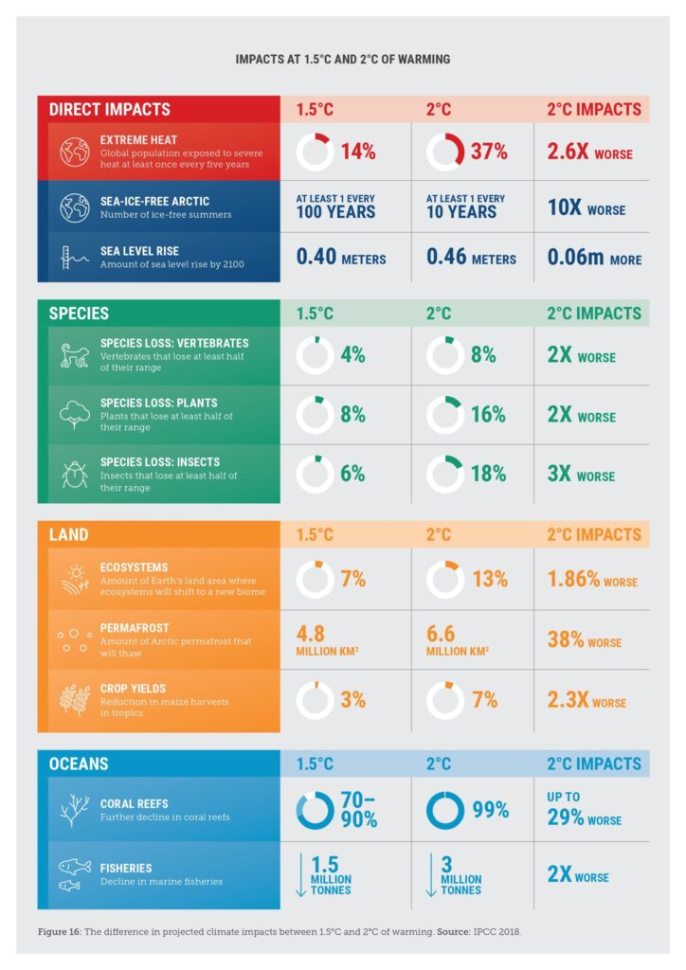

What needs to happen now?

- The solutions are out there to reduce emissions by at least 43% over the next seven years.

- The IPCC highlights that to achieve this we need to transition “from fossil fuels without carbon capture and storage (CCS) to very low- or zero-carbon energy sources, such as renewables or fossil fuels with CCS, demand-side measures and improving efficiency”.

- Governments, businesses, civil society and communities can work together to transform our energy, food, transport and manufacturing systems. This can be achieved through clear, courageous and concerted policies to further unlock the transformative power of financial markets, industry, and innovators. Momentum is building to tackle climate change.
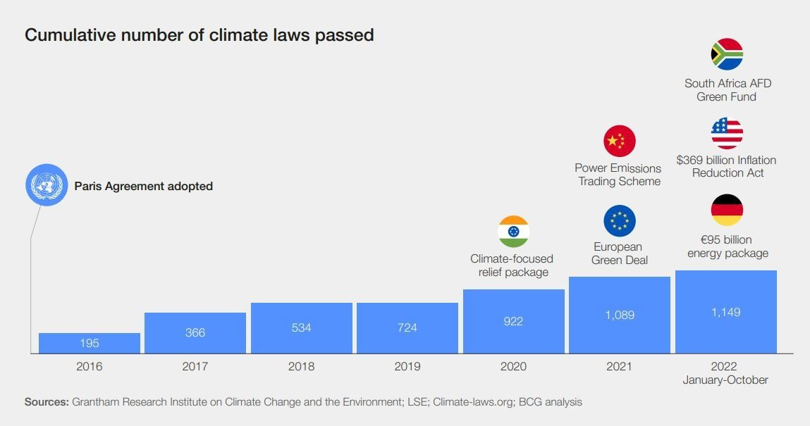

- The UN Secretary-General António Guterres outlined a major new Acceleration Agenda in his video message to launch the Synthesis Report, which includes:

- Ensuring net-zero electricity generation by 2035 for all developed economies and 2040 for the rest of the world.
- Ceasing all licensing or funding of new oil and gas – consistent with the findings of the International Energy Agency.
- Stopping any expansion of existing oil and gas reserves. Shifting subsidies from fossil fuels to a just energy transition.
- Establishing a global phase-down of existing oil and gas production compatible with the 2050 global net-zero target.
- Speeding-up efforts to deliver climate justice to those on the frontlines.

- We have seen a miraculous breakthrough in renewables, where solar and wind are now the cheapest source of new power in countries representing 90% of electricity generation, and electric vehicles are projected price parity with internal combustion engines in the next 2-3 years.

- We need similar breakthroughs across the so-called “hard-to-abate” sectors of heavy industry and long-haul transport – and this is where the World Economic Forum’s work with the First Movers Coalition (FMC) is leveraging the power of demand to accelerate the supply of transformational near-zero-emission solutions.

- Since it was launched at COP26 in 2021, 74 companies and 12 governments have joined this global, public-private coalition, which aims to decarbonize heavy industry and long-distance transport responsible for 30% of global emissions. To date, FMC represents a strong early market signal of $12 billion in demand for near-zero-emission solutions.

- And we need to catalyse similar breakthroughs to transform our food systems. There is no way to keep 1.5°C alive without stopping and reversing deforestation, transforming our food and land use systems and protecting ocean ecosystems.

- Today, agri-food systems are responsible for up to a third of emissions and are the primary driver of biodiversity loss. Our food and land use systems need to flip from carbon emitters to carbon sinks, and from a contributor to protectors of biodiversity, all while meeting global demand for food.

- The green transition has multiple benefits beyond the immediate mitigation of climate change impacts. It could create 24 million new jobs globally by 2030, according to the International Labour Organization. And protect the 1.2 billion workers in farming, fishing, forestry and tourism activities that rely directly on a healthy and stable environment.

- In the year from 2020 to 2021, employment in the renewable energy sector grew by 700,000, reaching 12.7 million jobs, according to the International Renewable Energy Agency.

- Climate action is now essential to drive sustainable development. Failure to act could shrink global GDP by up to 18% in the next 30 years, according to the Swiss Re Institute.

- The net-zero transition will require $125 trillion by 2050 in climate investment. While this level of investment has yet to be achieved, momentum is building. In 2021, the world spent $755 billion on low-carbon energy technologies, up 27% from the year prior.

- Guterres looked ahead to COP28, which will be held in November 2023 in Dubai, calling for “all G20 leaders to have committed to ambitious new economy-wide nationally determined contributions encompassing all greenhouse gases and indicating their absolute emissions cuts targets for 2035 and 2040. The transition must cover the entire economy. Partial pledges won’t cut it”.

